Primer ejercicio de las arenas (Hackerrank) :
import os

def poisonousPlants(p):
stack = []
max_days = 0

for plant in p:
days_to_die = 0

while stack and plant <= stack[-1][0]:
days_to_die = max(days_to_die, stack.pop()[1])

if not stack:
days_to_die = 0
else:
days_to_die += 1

max_days = max(max_days, days_to_die)
stack.append([plant, days_to_die])

return max_days

if __name__ == '__main__':
fptr = open(os.environ['OUTPUT_PATH'], 'w')

n = int(input().strip())

p = list(map(int, input().rstrip().split()))

result = poisonousPlants(p)

fptr.write(str(result) + '\n')

fptr.close()

Diagrama de flujo: 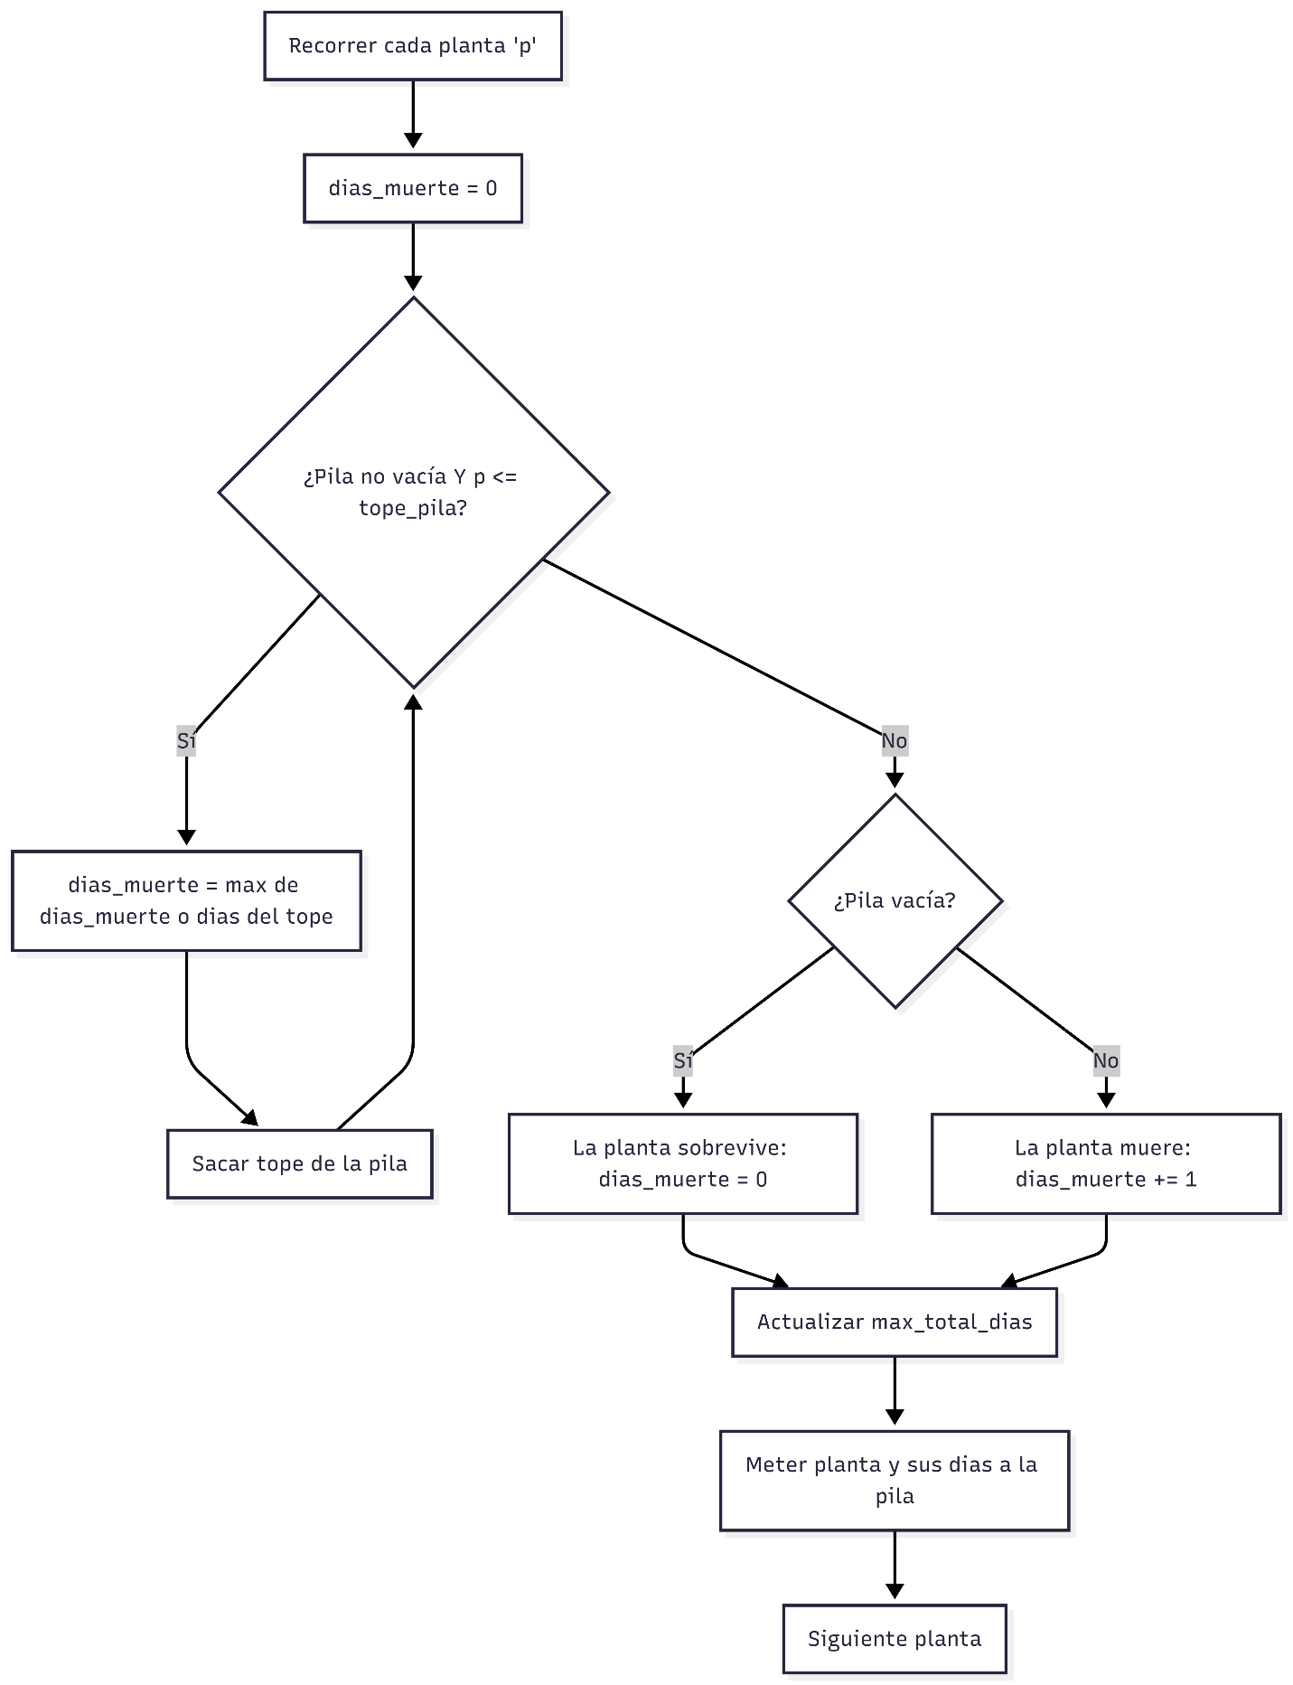
Segundo ejercicio de las arenas :
class MyQueue:
def __init__(self):
self.stack_in = []
self.stack_out = []

def enqueue(self, x):
self.stack_in.append(x)

def _prepare_output(self):
if not self.stack_out:
while self.stack_in:
self.stack_out.append(self.stack_in.pop())

def dequeue(self):
self._prepare_output()
if self.stack_out:
self.stack_out.pop()

def peek(self):
self._prepare_output()
if self.stack_out:
return self.stack_out[-1]

if __name__ == '__main__':
q = int(input())

queue = MyQueue()

for _ in range(q):
query = input().split()
tipo = query[0]

if tipo == '1':
queue.enqueue(query[1])
elif tipo == '2':
queue.dequeue()
elif tipo == '3':
print(queue.peek())

Diagrama de flujo:
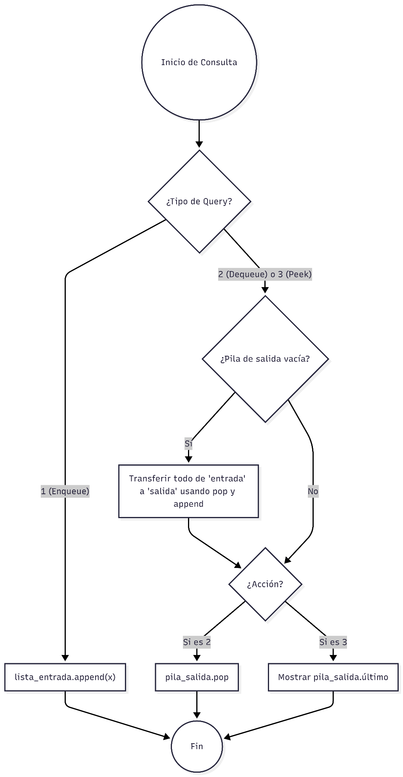
Tercer ejercicio de las arenas
import sys

def solve():
input_data = sys.stdin.read().split()
if not input_data:
return

n = int(input_data[0])
a = [int(x) for x in input_data[1:]]

stack = []
max_xor = 0

for x in a:
while stack:
current_xor = stack[-1] ^ x
if current_xor > max_xor:
max_xor = current_xor

if x < stack[-1]:
stack.pop()
else:
break

stack.append(x)

print(max_xor)

if __name__ == '__main__':
solve()

Diagrama de flujo:
